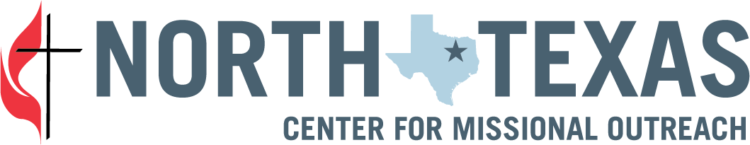
2023 Ministry With Grant Application

  - Description and Guidance:
In 2023, Ministry With grants will be available in two different cycles:
Ongoing microgrants will be available throughout the year. These grants of no more than $1,000 will be available to enable individuals and groups to start smaller projects because we know opportunities arise year-round.
The Fall Cycle will be open for applications September 1-October 15. These grant awards may be up to $10,000 per grant, with smaller grants also available.
Ministry With grants are for new efforts or efforts that expand existing ministries with particular emphasis on ministry with our neighbors.
Applications will be evaluated according to how they intend to live into our “ministry with” values:
- Come alongside neighbors in a spirit of friendship and mutuality. Listen to and learn from them.
- Build long-term relationships with neighbors.
- Discover the often-undervalued gifts, talents, dreams, desires, and connections of neighbors.
- Use a strengths-based approach that leverages the gifts and relationships of local partners.
- Adopt the iron rule: never do for others what they can do for themselves.
- Embody and demonstrate racial equity and anti-racism.
- Address systems that perpetuate suffering and inequity rather than only dealing with the symptoms.

To discuss your ideas or ask a question, please email Rev. Jessica Wright or call her at 972-526-5018.

Full Name of Ministry Leader:
Phone Number:
Email:
If Different, Name and Contact information of Applicant Author:
Church Affiliation:
District:
Title of Ministry/Effort:
Funding Amount Requested:
Questions:
- What is your vision for this ministry with your neighbors?
- Who are you? What is it about your congregation that has prepared you and gifted you for this ministry?

- Who is your neighbor? What is it about your community that cries out for this ministry?

- What gifts/skills/assets already exist in your church and community that could be leveraged for this ministry?

- What difference(s) do you hope this ministry will make in the short-term and long-term?

- How will disciples of Jesus Christ be made through this ministry? (*see below for definition)

- How have those that you will be in ministry with shaped this vision? Who from your community has asked for this?

- Who is on the leadership team for this ministry? How are BIPOC (Black, Indigenous, Person of Color) persons from your church, or partner churches, communities, or other organizations contributing to leadership of this effort?

- What is the ideal timeline for launching this ministry?

- What resources are in place to make this ministry sustainable?

- What difference would a CMO Ministry With grant make?

Attached Documents:
- Your church’s or organization’s budget for the applicable budget year.
- A detailed/itemized budget for the work or program you intend to fund with a Ministry With Grant.
- Other documents you feel are helpful for the application. (optional)

In our view, making disciples can happen in a variety of ways. Amid a church’s ministry with its neighbors, church members could be intentional about recognizing and seizing opportunities to share their faith and invite their neighbors onto a pathway of discipleship. At the same time, church members could find themselves stretched through this ministry, their experience of the Holy Spirit deepened through this experience. We invite a broad view to this question, beyond but possibly including numeric gains.

